**MAHARASHTRA STATE BOARD OF TECHNICAL EDUCATION, MUMBAI**

Shri Vishweshwar Shikshan Prasarak Mandal’s

# Vishweshwarayya Abhiyantriki Padvika Mahavidyalaya, Almala

Certificate

This is to certify that Mr. Harsh Moreshwar Kale, a student of our institute in the **Third** year **Computer Engineering (CO5I),** has successfully completed the micro project report on **“Java Programming”** for the course **“Advanced Java Programming (22517)”** as part of the curriculum prescribed by the Maharashtra State Board of Technical Education, Mumbai.

For partial fulfillment of “**Diploma in Computer Engineering**” during the academic year 2022-23.

GUIDE HOD

Mr. Sugare D. D. Mr. Kazi A. S. M.

PRINCIPAL

Mr. Dharashive P.S

**MAHARASHTRA STATE BOARD OF TECHNICAL EDUCATION, MUMBAI**

Shri Vishweshwar Shikshan Prasarak Mandal’s

# Vishweshwarayya Abhiyantriki Padvika Mahavidyalaya,

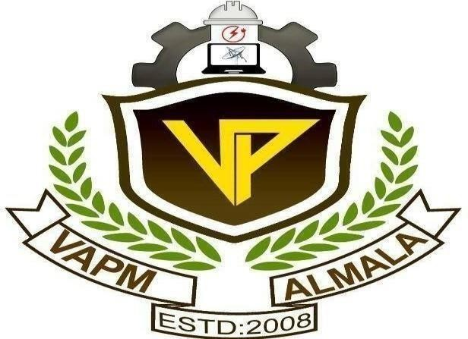Almala.

Department of Computer Engineering Academic Year-2022-23

Micro-Project Report On

**“Java Programming”**

Submitted By

Enrollment No Name of Student

2110950051 Mr. Harsh Moreshwar Kale

Under the Guidance of

Mr. Sugare D. D.